Experience Luxury Living with World- Class Amenities at Faletti’s

Faletti’s Service Apartment at City Scape Height's: World-Class Living Redefined

Modern urban living demands more than just a place to stay—it requires comfort, security, convenience, and a lifestyle that supports both personal and professional needs. Faletti’s Service Apartments at City Scape Height's is thoughtfully designed to meet these expectations, offering world-class amenities curated for residents who value efficiency, luxury, and peace of mind.
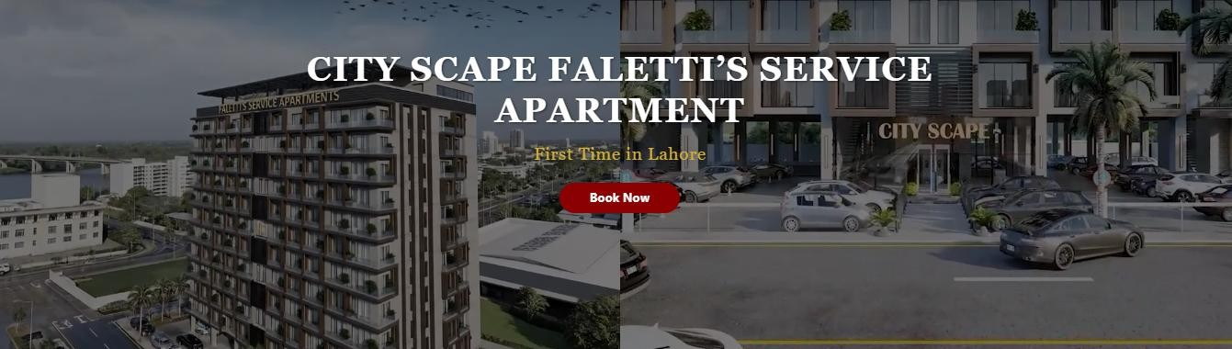

Developed with excellence and managed in collaboration with MUN O SALVA Associates and Motasim & Sons Associates, this premium serviced apartment project sets a new benchmark for contemporary living. Whether you are a business professional, long-term resident, or investor, Faletti’s Service Apartments offers an unmatched living experience in a prime urban setting.

City Scape Height's – A Prime Urban Address

City Scape Height's is strategically located to provide seamless connectivity, modern infrastructure, and a refined lifestyle environment. The project blends architectural elegance with functional design, ensuring residents enjoy both aesthetic appeal and everyday practicality.

Key highlights of the location include:

- Easy access to commercial hubs and business districts

- Proximity to shopping centers, healthcare facilities, and dining options

- A peaceful environment within a secure, well-planned development

This prime location makes Faletti’s Service Apartments an ideal choice for professionals and families seeking convenience without compromising luxury.

World-Class Amenities at Faletti’s Service Apartment

At the heart of this project lies a comprehensive range of world-class amenities designed to elevate everyday living. Each amenity has been carefully planned to ensure safety, comfort, and operational efficiency.

24/7 Security & CCTV Surveillance

Security is a top priority at Faletti’s Service Apartments. The entire premises are monitored around the clock through a comprehensive CCTV surveillance system, ensuring residents feel safe at all times.

Key security features include:

- 24/7 monitored CCTV cameras

- Controlled access points

- Trained security personnel on duty

This robust security infrastructure provides residents with complete peace of mind, whether they are at home or away.
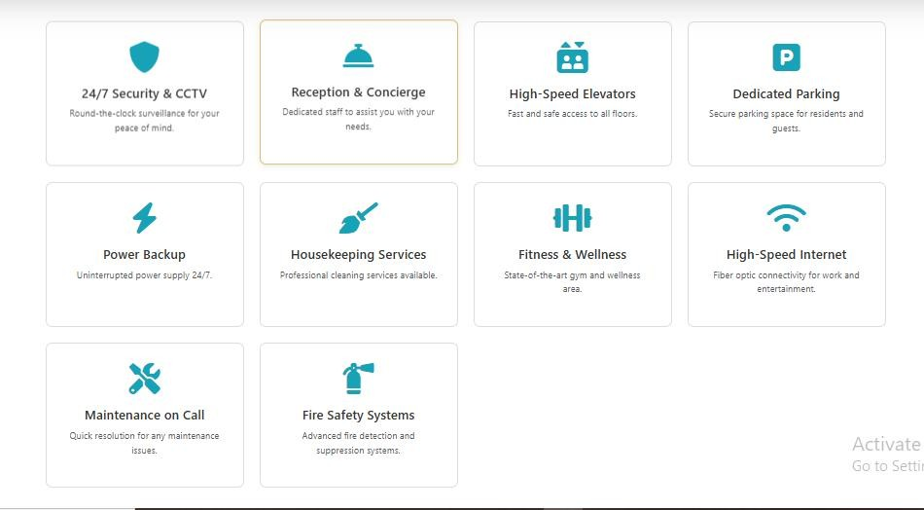

Reception & Concierge Services

A professionally managed reception and concierge service enhances the living experience by offering personalized assistance whenever needed.

Services include:

- Guest management and visitor handling

- Parcel and delivery assistance

- Daily resident support and inquiries

The presence of dedicated staff reflects the premium standards upheld by

MUN O SALVA Associates and Motasim & Sons Associates.

High-Speed Elevators

To ensure effortless movement within the building, high-speed elevators are installed to provide quick, smooth, and safe access to all floors.

Benefits:

- Reduced waiting time

- Advanced safety mechanisms

- Smooth operation for residents and guests

This feature is especially valuable in a modern high-rise like City Space Height's.

Dedicated Parking Facilities

Parking convenience is an essential part of urban living. Faletti’s Service Apartments offers secure and dedicated parking spaces for both residents and guests.

Highlights:

- Clearly marked parking areas

- Secure access control

- Convenient proximity to elevators

This ensures hassle-free parking and added security for vehicles.

⚡ Power Backup – Uninterrupted Living

Power interruptions can disrupt daily routines. To address this, the project features a 24/7 power backup system that ensures uninterrupted electricity supply.

Advantages:

- Continuous power for essential services

- Backup for elevators, lighting, and internet

- Peace of mind during outages

- Residents can work, relax, and live comfortably without concerns.

Housekeeping Services

Maintaining cleanliness is effortless with professional housekeeping services available to residents.

Services may include:

- Routine cleaning and maintenance

- Professional hygiene standards

- Flexible service scheduling

This amenity supports a stress-free lifestyle, particularly for busy professionals.

Fitness & Wellness Facilities

A healthy lifestyle is an integral part of modern living. Faletti’s Service Apartments includes a state-of-the-art gym and wellness area designed to support physical and mental well-being.

Features include:

- Modern fitness equipment

- Clean and well-ventilated space

- Convenient on-site access

Residents can maintain their fitness routines without leaving the building.

High-Speed Internet Connectivity

In today’s digital world, reliable internet is essential. The apartments are equipped with fiber optic high-speed internet, ideal for work, streaming, and communication.

Benefits:

- Seamless remote working

- High-speed streaming and browsing

- Stable connectivity across the property

This makes Faletti’s Service Apartments especially attractive to business professionals.

Maintenance on Call

Quick problem resolution is ensured through on-call maintenance services available to residents.

Key advantages:

- Fast response times

- Skilled technical staff

- Preventive and emergency maintenance

This service ensures uninterrupted comfort and long-term property upkeep.

Advanced Fire Safety Systems

Safety is further reinforced through modern fire detection and suppression systems installed throughout the building.

Safety features include:

- Smoke detectors and alarms

- Fire suppression mechanisms

- Clearly marked emergency exits

These systems meet modern safety standards and protect both residents and property.

Developed & Managed by Trusted Names

The collaboration between MUN O SALVA Associates and Motasim & Sons Associates ensures that Faletti’s Service Apartments adheres to the highest standards of construction, management, and service delivery.

Their expertise guarantees:

- Professional property management

- High-quality finishing and maintenance

- Long-term value for residents and investors

Why Choose Faletti’s Service Apartment at City Scape Height's?

✔ Premium serviced living

✔ World-class amenities
✔ Secure and professional management
✔ Ideal for professionals and long-term stays
✔ Strong investment potential

Frequently Asked Questions (FAQs)

Q1: What makes Faletti’s Service Apartment different from regular apartments?

Faletti’s Service Apartments offers hotel-like services, world-class amenities, and professional management, making it ideal for modern professionals.

Q2: Is the apartment suitable for long-term stays?

Yes, it is designed for both short-term and long-term residents with full- service facilities.

Q3: Who manages City Scape Height's?

The project is managed by MUN O SALVA Associates and Motasim & Sons Associates, ensuring high operational standards.

Q4: Are security services available 24/7?

Yes, the building is protected by round-the-clock security personnel and
CCTV surveillance.

Q5: Does the apartment support remote working?

Absolutely, High-speed fiber optic internet and power backup make it perfect for remote work.

Conclusion:

Faletti’s Service Apartments at City Scape Height's is more than just a residence—it is a complete lifestyle solution. With world-class amenities, advanced security, professional management by MUN O SALVA Associates and Motasim & Sons Associates, and a prime urban location, it stands as a benchmark for modern serviced living.

Whether you are looking for a refined place to live or a high-potential real estate investment, Faletti’s Service Apartments delivers comfort, reliability, and long-term value—all under one roof.

